South Asia Foundation (SAF)

Report on Activities for the Year 2017

BRIEF INTRODUCTION

Founded by UNESCO Goodwill Ambassador Madanjeet Singh in 2000, the South Asia Foundation (SAF) is a secular, non-profit and non-political organization, comprising eight autonomous chapters in: Afghanistan, Bangladesh, Bhutan, India, Maldives, Nepal, Pakistan and Sri Lanka. SAF’s core objective is to promote regional cooperation through a number of UNESCO Madanjeet Singh Institutions of Excellence in the eight SAARC countries, with courses in Preservation of Cultural Heritage (Kabul), Human Rights and Common Law( Dhaka), Forestry Studies (Bumthang, Bhutan), Journalism (Chennai), Kashmir Studies (Srinagar), Regional Cooperation (Pondicherry), Green Energy Technology (Pondicherry), Development Studies (Kathmandu), Visual Arts (Lahore), Water Management (Moratuwa, Sri Lanka).

(For details, please visit SAF website www.southasiafoundation.org)

The SAF Governing Council comprises of eight Chairpersons & Vice-Chairpersons of SAF chapters, the details of which are given below:

Afghanistan:
Chairperson: Prof. Omara Khan Masoodi, Former Director, Kabul National Museum
Advisor: Hon'ble Sayed Makhdoom Raheen, Ministry of Information and Culture, Kabul.

Bangladesh:
Chairperson: Dr. Kamal Hossain, Former Minister of Foreign Affairs, Dhaka
Vice Chairperson: Prof. Jamilur Reza Choudhury, Vice Chancellor, University of Asia Pacific,
Dhaka

Bhutan:
Chairperson: Hon. Lyonpo Sangay Ngedup, Former Prime Minister and Minister for Agriculture, Bhutan
Vice-Chairperson: Ms. Chime P. Wangdi

India:
Chairperson: Shri Mani Shankar Aiyar, Former Minister and Member of Parliament
Vice-Chairpersons: Dr. Syeda Hameed, Former Member of Planning Commission, New Delhi
Prof. Veena Sikri, Professor & Ambassador, Convener, South Asia Women’s Network (SWAN)

Nepal:
Chairperson: Dr. Nischal Nath Pandey, Kathmandu, Nepal
Vice-Chairperson: Dr. Jan Sharma, Nepal

Pakistan:
Chairperson: Prof. Salima Hashmi, Director, School of Visual Arts, BNU, Lahore, Pakistan
Vice Chairperson: Mr. Najam Sethi, Editor-in-Chief, Friday Times, Lahore, Pakistan

Sri Lanka:

Chairperson: Hon. Mrs. Chandrika B. Kumaratunga, Former President of Sri Lanka
Vice Chairperson: Dr. Ronald Silva, Chancellor, Moratuwa University, Sri Lanka

Each of the eight chapters may, at an annual meeting of the Governing Council or at any other special meeting, present a proposal that promote regional cooperation. A decision to accept or reject a proposal will be taken by unanimity. The responsibility for implementing the approved projects is entirely that of the Chairpersons and their Advisory Board members. In conformity with the general principle that institutional projects funded by SAF would bear at least half the costs, either in funds or in kind.

Since August 2006, SAF has been recognized as an Apex Body of South Asian Association of Regional Cooperation (SAARC), Kathmandu, Nepal, and its aims and objectives are in conformity with the spirit and purpose and principles of the SAARC Charter.

SAF has been admitted into an official relationship with the United Nations Educational, Scientific and Cultural Organization (UNESCO) Paris, France since 17th October 2006.

UNESCO Director-General Madame Irina Bokova announced on 26 October 2010, that the 12 SAF institutions can use the UNESCO logo as long as it is always associated with Madanjeet Singh's name and his official title of UNESCO Goodwill Ambassador. Consequently, all the Institutions of Excellence have been renamed as indicated below:

- UNESCO Madanjeet Singh Centre for Preservation of Afghanistan’s Cultural Heritage (UMCPACH) (Afghanistan)
- UNESCO Madanjeet Singh South Asian Institute of Advanced Legal and Human Rights Studies (UMSAILS) (Bangladesh)

- UNESCO Madanjeet Singh Centre for South Asia Forestry Studies (UMCSAFS) (Bhutan)

- UNESCO Madanjeet Singh Centre of South Asian Journalism (UMCSAJ) (Chennai, India)

- UNESCO Madanjeet Singh Institute for South Asia Regional Cooperation (UMISARC) (Puducherry, India)

- UNESCO Madanjeet Singh School of Green Energy Technology (UMSGET) (Puducherry, India)

UNESCO Madanjeet Singh Centre of Development Studies and Regional Cooperation (UMCDSRC) (Nepal)

UNESCO Madanjeet Singh Institute for South Asian Arts (UMISAA) (Lahore, Pakistan)

UNESCO Madanjeet Singh Centre for South Asia Water Management (UMCSAWM) (Moratuwa, Sri Lanka)

Group Scholarships, sixteen or eight students, depending on the quantum of support that SAF extends to these Institutions of Excellence, two/one each from each chapter, based on gender equity are awarded by these Institutions representing all the eight chapters of the SAF. The underlying principle being that the Institutions of Excellence would earmark 70% of the funds provided on group scholarships and 30% on scholarship related expenditure, comprising items such as the purchase of books, inviting short-term teachers and instructors from other SAARC countries, temporary staff for projects such as workshops, research etc .

The Group Scholarships Scheme proved a great success in furthering the principle of regional cooperation.

LIST OF ACTIVITIES HELD FROM JANUARY 2017 TO DECEMBER 2017

S.No | Activity | Venue | Date
SAF-AFGHANISTAN
- 1) | Visit of Afghanistan Ambassador to SAF-India Office  Visit of H. E Ambassador Mr. Shaida Mohammad Abdali along with Mr. Hamid Tahzeeb and Mr. Abdulhaq Azad held discussion with SAF-India Chairperson Mr. Mani Shankar Aiyar, Vice Chairperson Prof. Veena Sikri, SAF-India Trustee Mr. M K Raina. | SAF-India Office, Delhi | 18th May 2017
- 2) | UMISAA scholars Mr. Sher Ali & Ms. Lati Attaii selected to participate in young subcontinent project of Serendipity Arts  UMISAA scholars, Sher Ali and Ms. Lati Attaii from Afghanistan nominated to participate in young subcontinent project of Serendipity Arts Festival. The project curated by Riyas Komu and it showcased works of 21 young emerging artists of the Indian subcontinent. The exhibition happened in Public Work Department of Goa - India 15th -22nd Dec 2017. | Goa, India | 15th Dec. 2017
SAF-BHUTAN
- 3) | Feedback From Mr. Jamiyang Norbu, SAF-Scholar, UNESCO Madanjeet Singh Institute of Kashmir Studies (UMIKS)  I am Jamyang Norbu studying MA in Kasmir and south Asia Studies in Jamia Millia Islamia.  As far as I am concerned, there are not much other International Fellowships available for MA in Kashmir and south Asia Studies. In this respect, I am very much privileged and grateful to South Asia Foundation– Prestigious Madanjeet Singh Scholarship. Therefore, I would wholehearted thank for fellowship opportunity through SAF that I have received. “In an age of cynicism, the South Asia Foundation is an experiment in idealism.” It provides an excellent opportunity to interact with other SAF Fellows from different South Asian Countries which would not have been possible under any national or institutional fellowships.  My Kudos to South Asia foundation- India, for making timely stipend and providing helping hand for comfortable stay and fruitful continuation of academic session. | Kashmir University, Srinagar, India | 28th April 2017
- 4) | An open mobile video competition was organized by Madanjeet group scholarship students for the students studying at UMCSAFS  An open mobile video competition was organized by Madanjeet group scholarship students for the students studying at the College of UNESCO Madanjeet Singh Centre for South Asia Forestry Studies (UMCSAFS). Students were asked to form a team to create 2-5 minutes video that explains and inspires university students and communities to learn more about what natural resources mean and how they can contribute in sustainable management of Natural resources in their country. Each video was deliberated by panel of judges and prices were awarded to the winners along with the certificates. It was participated by 7 teams comprising of 41 students from the college. | UMCSAFS, Bhutan | 26th Oct. 2017
SAF-INDIA
- 5) | UGC-Human Resource Development Center organized a Special Interaction Programme in collaboration with UMIKS & SAF  Press Release  UGC-Human Resource Development Center organized a Special Interaction Programme at the end of the 3rd Semester of M. A. Programme, “Kashmir and South Asia Studies” at the UGC-HRDC, Jamia Millia Islamia in collaboration with UNESCO Madanjeet Singh Institute of Kashmir Studies, UMIKS, University of Kashmir and South Asia Foundation (SAF).  Prof Talat Ahmad, Vice Chancellor; JMI, Madame France Marquet, Principal Trustee, South Asia Foundation, Prof. Veena Sikri, Vice Chairperson South Asia Foundation & former Ambassador to Bangladesh; Dr. Syeda Saiyidain Hameed, Member South Asia Foundation & former Member, Planning Commission; Mr. Prabhakaran Menon, CEO, South Asia Foundation including several Jamia faculty members along with students graced the occasion and participated in the interaction programme.  On the occasion, Chief Guest Prof. Talat Ahmad presented a portrait of Madanjeet Singh to Madame France Marquet, Principal Trustee, SAF. In his address Prof. Talat Ahmad remarked that the vision and mission of the South Asia Foundation, is to promote Peace and Regional Cooperation among the South Asian Countries. While speaking on the personality of Goodwill Ambassador he said that Madanjeet Singh was believer of secularist philosophy and had great commitment towards building peaceful relations and atmosphere between the countries and this course is the best example in that direction.  Speaking on the occasion the Principal Trustee of the Foundation Madame France emphasized that the students from Kashmir and other South Asian Countries would be the brand Ambassadors for peace. She added that the dream of Madanjeet Singh was to see South Asia as peaceful and prosperous region and we all need to work together to make his dream come true. Prof. Anisur Rahman, Director, UGC-HRDC, JMI presented a portrait to the Vice Chancellor, Jamia Millia Islamia. In memory of Madanjeet Singh, mementos were also given to all the dignitaries.  Dr. Muslim Jan Course Coordinator UMIKS, University of Kashmir presented a detailed report of the 3rd Semester academic activities including special lectures by eminent scholars like Dr. Henrik Chetan Aspengren, Centre for Colonial and Postcolonial Studies, Linnaeus University, Sweden on the topic Social Science and the Question of Modernity in South Asia and Dr. Syeda Afshana, Media Education and Research Center, University of Kashmir on the topic Gender and Conflict in South Asia. Good Governance and Human Development in South Asia by Dr. Niharika Tiwari and Role of Media in South Asia by Ms. Jyoti Malhotra, Freelance Journalist.  Prof. Anisur Rahman, Director, UGC-HRDC, in his welcome address also outlined activities of the forth coming Semester. In the end Vice Chancellor appreciated the efforts of Director UGC HRDC, Prof. Anisur Rehman and Coordinator UMIKS and also congratulated the whole team. The students were very happy and shared their experiences with the dignitaries. The Programme ended with the vote of thanks. | Jamia Millia Islamia University, Delhi, India | 12th Jan. 2017
- 6) | UMISARC organised a series of lectures on Conflict and Cooperation in South Asia  UMISARC and Centre for South Asian Studies, Pondicherry University organized a series of lectures on “Conflict and Cooperation in South Asia” on 2nd March, 2017 and “Indo-Pakistan Relations: A Kashmir Perspective” on 3rd March, 2017 by Prof. Gopalji Malviya, Former Dean of School of National Security Studies, Central University of Jammu | UMISARC, Pondicherry University, India | 2nd Mar 2017
- 7) | Role of a journalist as an effective storyteller - Interactive Session Aman Ali, former USA Today Reporter and New York based stand-up comedian | UMCSAJ, Chennai | 3rd Mar, 2017
- 8) | UMISARC organised the lecture on 'Radicalisation in Pakistan Implications for India by Prof. Alok Bansal'  UMISARC Pondicherry University organized a lecture on 'Radicalisation in Pakistan Implications for India by Prof. Alok Bansal' | UMISARC, Pondicherry, India | 6th Mar 2017
- 9) | UMISARC organised lectures on 'China's South Asia Policy, China-India Relations and India's Nuclear Disarmament Policy  UMISARC Pondicherry University organized a lecture on 'China's South Asia Policy, China-India Relations and India's Nuclear Disarmament Policy’ by Prof. Swaran Singh, School of International Studies, Jawahar Lal Nehru University. | UMISARC, Pondicherry, India | 15th Mar 2017
- 10) | Dr Nishchal N. Pandey, Chairperson, SAF-Nepal, addressed UMIKS scholars at Jamia Milia Islamia University  Dr Nishchal N Pandey, Chairperson, SAF-Nepal, addressed UMIKS scholars on 16th March, 2016 at Jamia Milia University, New Delhi. The lecture was on "SAARC and current situation in South Asia". All SAF scholars of UMIKS who are currently at Jamia Milia University were present along with the faculty.  The SAF scholars were also pleased to get a ‘different’ perspective and we also discussed various issues related to the scholarships. | Jamia Milia Islamia University, Delhi, India | 16th Mar 2017
- 11) | UMSGET organized lecture by SAF scholar Ms.Marzia, on 'Small Wind Turbines: Fabrications and installation. | UMSGET, Pondicherry | 16th Mar, 2017
- 12) | UMISARC organised lectures on 'Foreign and Regional Interventions in West Asia by Prof. A.K. Pasha'  UMISARC organised the lectures by Prof. A.K. Pasha on  Foreign and Regional Interventions in West Asia – 20 March 2017;  Strategic developments in West Asia and implications on South Asia - 20 March 2017;  GCC's Quest for Gulf Security and India – 21 March 2017 and  India's relations with West Asia: New Engagements - 21 March 2017 | UMISARC, Pondicherry, India | 20th Mar. 2017
- 13) | UMISARC organised the lecture on ' Implications for India by Dr. Mohan Guruswamy on 23 March 2017  UMISARC organised the lecture on ' Rising China - Implications for India by Dr. Mohan Guruswamy, Founder & Chairman of Centre for Policy Alternatives Society. | UMISARC, Pondicherry, India | 23rd March 2017
- 14) | UMISARC organized lecture on ' India-Maldives Relations and India-Sri Lanka Relations by Shri. Sathiya Moorthy, Observer Research Foundation, Chennai  UMISARC organised the lectures on 'India- Maldives and India- Sri Lanka ' by Prof. Shri. Sathiya Moorthy, Observer Research Foundation, Chennai Chapter | UMISARC, Pondicherry | 24th March 2017
- 15) | Workshop on SUSTAINABLE BUILDING TECHNOLOGIES by Mr.G. Shankar, Architect | UMSGET, Pondicherry | 24-25 March 2017
- 16) | UMISARC organized a lecture on 'Gender, Peace and Security by Dr. Meenakshi Gopinath on 28 March 2017  UMISARC organised a lecture on 'Gender, Peace and Security by Dr. Meenakshi Gopinath, Founder & Director, Women in Security, Conflict Management and Peace (WISCOMP), New Delhi | UMISARC, Pondicherry | 28th March 2017
- 17) | UMISARC organized a lecture on 'Space and Society by Dr. K. Kasturirangan  UMISARC organized a lecture on 'Space and Society by Dr. K. Kasturirangan, Chancellor, JNU, New Delhi and Former Chairman of ISRO | UMISARC, Pondicherry, India | 28th March 2017
- 18) | UMIKS-JMI organised a special programme on the occasion of the 93rd Birth Anniversary of UNESCO Goodwill Ambassador Madanjeet Singh  UGC-Human Resource Development Centre, Jamia Millia Islamia, New Delhi organized the Special Programme on the occasion of Birth Anniversary of  UNESCO Goodwill Ambassador Madanjeet Singh on15th April 2017 | Jamia Milia Islamia University, Delhi | 15th April 2017
- 19) | Address source of inequality: Bangladeshi economist  Economist Rehman Sobhan poses at a programme on Monday while delivering the second Madanjeet Singh memorial lecture on “Structural sources of inequality in South Asia” at the Pondicherry University in India. PTI  Pondicherry, PTI  Access to rural population to tangible assets and making farm and manufacturing sector workers equity partners are key factors in addressing “growing problems of inequality,” noted Bangladeshi economist Rehman Sobhan said on April 17.  Also, establishment of a 21st century Agrarian Reforms Commission and the “need to address the sources of inequality” were important, said Sobhan, who is chairman of the Centre for Policy Dialogue, a think-tank of Bangladesh.  He was delivering the “Unesco Goodwill Ambassador Madanjeet Singh second memorial lecture on addressing the structural sources of inequality in South Asia” at Pondicherry University.  “Establishment of an agrarian reforms commission, providing access for rural population to tangible assets, ensuring better quality education in institutions run by the government and also electoral reforms” are key factors needed to address the growing problems of inequality, he said.  “Even within the prevailing inequitable social dispensation across South Asia there is no reason why we can't explore agrarian reforms which are politically feasible as well as economically sustainable.” Economic intervention programmes by the governments across South Asia such as employment guarantee schemes, welfare programmes and subsidies had helped reduced poverty, he said. "But inequality and social disparity have widened in the region.”  Suggesting mandatory offering of equity stake in the value addition process, he said, “It is actually making a farmer a business partner of the corporate entity which finally sells his produce.”  The ultimate aim should be to move towards a “common school system which provides high quality public education.”  Chairman of Kasturi and Sons Ltd and President of Madanjeet Singh Foundation N Ram outlined the need for South Asian countries to promote understanding.  Chairperson of South Asia Foundation (India chapter) Mani Shankar Aiyar, Vice-Chancellor (officiating) of Pondicherry University Anisa Basheer Khan and Representative of the South Asia Foundation to Unesco France Marquet were among those who spoke. | UMISARC, Pondicherry University | 16th April 2017
- 20) | JMI organised a special programme on the occasion of the 93rd Birth Anniversary of UNESCO Goodwill Ambassador Madanjeet Singh  UGC-Human Resource Development Centre, Jamia Millia Islamia, New Delhi organized a Special Programme on the occasion of Birth Anniversary of UNESCO Goodwill Ambassador Madanjeet Singh on15th April 2017 at10:30 AM at UGC-HRDC, JMI  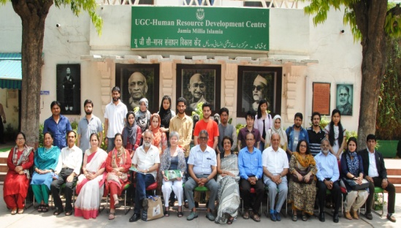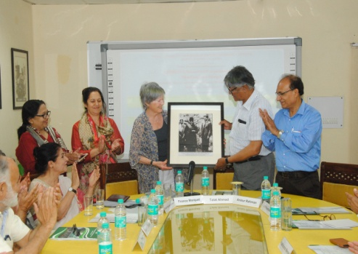Group Photograph Mme. France Marquet, Principal Trustee,  Present framed Photograph of "UNESCO  Goodwill ambassador Madanjeet Singh  and Maulana Abul Kalam Azad for the VC  Jamia Millia Islamia to Prof. Talat Ahmad | Jamia Millia Islamia University, Delhi, India | 17th April 2017
- 21) | Governance, Human Rights and Regional Cooperation in South Asia: Opportunities and Challenges of Globalization  Two Day International Seminar is organised On Governance, Human Rights and Regional Cooperation in South Asia: Opportunities and Challenges of Globalization. | Jamia Millia Islamia University, Delhi, India | 20th April 2017
- 22) | Lecture on “Lawarence Dana Pinkham Memorial Lecture - Free press and the laws of defamation, contempt and sedition” by Justice Ajit Prakash Shah, Former Chief Justice, Delhi & Madras High Courts | UMCSAJ, Chennai | 3rd May, 2017
- 23) | MoU renewed between South Asia Foudnation & UMCSAJ (UNESCO Madanjeet Singh Centre of South Asian Journalism) on 5th June 2017  MoU renewed between South Asia Foudnation & UMCSAJ (UNESCO Madanjeet Singh Centre of South Asian Journalism) on 5th June 2017 for three years | India | 2nd June 2017
- 24) | Lecture on “The Dravidian Movement” By Prof A.R Venkatachalapathy, Madras Institute of Development Studies | UMCSAJ, Chennai | 5th July, 2017
- 25) | Cross-border Philanthropy: An Indian diplomat who offered to fund his alma mater in Lahore  Lahore’s Government College’s Vice Chancellor Khalid Aftab wanted to retain the institutional memory of the pre-Partition Ravians — as old GC students were called — who had moved to India. | Lahore, Pakistan | 10th July 2017
- 26) | Lecture on “The state of Indian Agriculture” by Mr Venkatesh Athreya, Advisor, M.S. Swaminathan Research Foundation, Chennai | UMCSAJ, Chennai | 12th July 2017
- 27) | Lecture on “The Changing Roles of the News Media in South Asia” By Mr N. Ram, Chairman, Kasturi and Sons Limited | UMCSAJ, Chennai | 17th July, 2017
- 28) | Lecture on “The Palestine Question” By Mr Stanly Johny, Assistant Editor, The Hindu | UMCSAJ, Chennai | 19th July 2017
 | Mr Sashi Kumar, Director, UNESCO Madanjeet Singh Centre of South Asian Journalism (UMCSAJ) met UMCSAJ's alumni from Nepal  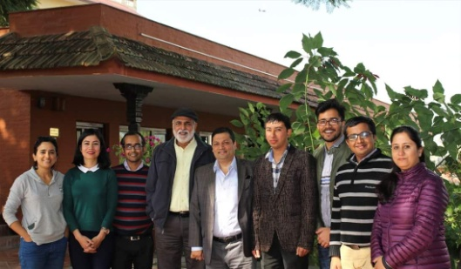  Left to Right: Ms. Prerana Marasini; Ms. Shreejana Shrestha; Mr. Abhaya Raj Joshi; Mr. Sashi Kumar, Director, UMCSAJ; Dr. Nischal N Pandey; Chairman, SAF-Nepal; Mr. Neeraj Roy; Mr. Santosh Ghimire; & Ms. Reecha Aryal | Kathmandu, Nepal | 5th Nov. 2017
- 29) | Prof. Salima Hashmi gives Delhiites and students a glimpse of art and art education in Pakistan  A lecture series in Delhi by the renowned Pakistani artist Prof. Salima Hashmi provided some interesting insights in the Pakistan art educations sphere.  Her talk on ‘Contemporary Arts of Lahore’ organised by Dalmiya Foundation on the evening of Nov. 2, 2017, hosted by Vasundhara Dalmiya, took place at the India International Centre, a known hub of culture and philosophical endeavour. People thronged the auditorium, which was packed to capacity. In fact, latecomers had to stand as the seats filled up. | IIC, Delhi, India | 9th Nov. 2017
- 31) | Special lectures organized at UMISARC on the occasion of SAARC Charter Day Dr. Omara Khan Masoudi and Mr. Hamidullah Arefi delivered lectures | UMISARC, Pondicherry University, India | 7th Dec., 2017
- 32) | 33rd SAARC Charter Day Celebrations at UNESCO Madanjeet Singh Centre of Green Energy Technology (UMSGET) | UMSGET, Pondicherry University, India | 8th Dec. 2017
- 33) | SAF Governing Council Meeting held on 9th Dec 2017  South Asia Foundation Annual Governing Council meeting held on 9th December, 2017 at South Asia Foundation-India office in Delhi  Mr Mani Shankar Aiyar, Chairperson, SAF-India chaired the meeting. The following members were presented:  SAF Chapters  - Mr Mani Shankar Aiyar, Chairperson, SAF-India  - Mr. Omara Khan Masoudi, Chairperson, SAF-Afghanistan  - Mr. Hamidullah Arefi, Secretary, SAF-Afghanistan  - Dr. Kamal Hossain, Trustee MSF & Chairperson, SAF-Bangladesh  - Prof. Jamilur Reza Choudhury, Vice-Chairperson, SAF-Bangladesh  - Lyonpo Sangay Ngedup, Chairperson, SAF-Bhutan  - Dr. Syeda Hameed, Trustee MSF & Vice-Chairperson, SAF-India  - Dr. Nishchal Nath Pandey, Trustee MSF & Chairperson, SAF-Nepal  - Prof. Salima Hashmi, Trustee MSF & Chairperson, SAF-Pakistan  - Prof. Uma Coomaraswamy, Representative, SAF-Sri Lanka  MSF Members  - Mr. N Ram, President, Madanjeet Singh Foundation  - Madame France Marquet, Principal Trustee MSF & SAF  - Dr. Armin Dobler, Trustee MSF  - Mr Navin B Chawla, Advisor, MSF  Special invitees  - Prof. Veena Sikri, Vice- Chairperson, SAF-India  - Mr KJS Prasada Rao, Consultant, MSF  - Mr P K Prabhakaran, CEO, SAF-India  - Mr Sunil Kumar Binjola, DO, SAF-India | SAF-India premises, New Delhi, India | 9th Dec. 2017
- 34) | Lectures organized in UMCSAJ, Chennai  A series of about 40 lectures were organized in a year from January 2017 to December 2017 at UMCSAJ, Chennai by various prominent speakers including talks by Dr. Omara Khan Masoudi and Mr. Hamidullah Arefi on 8th December on SAARC Charter Day. | UMCSAJ, Chennai
SAF- NEPAL
- 34) | Mr Koshal Hamal, Alumni of UNESCO Madanjeet Singh Institute for South Asian Arts (UMISAA) Art work is being exhibited  Koshal Hamal, Visual Artist, and SAF, UMISAA Alumni's works are engaged in a synthesis of appropriation, combining Western visual culture with the historical references of South Asian aesthetics-including miniature painting. His appropriations are deeply layered and nuances, interrogating established norms-social, political, and aesthetic-where can break down binary and categories into something new. His works reveal a deep desire of visual play weather through his exquisitely refined miniature painting technique to conceptual installations that provides nuanced narratives of the local and global. | The India Art Fair, Exhibition Grounds, Okhla Industrial Estate, Delhi, India | 2nd Feb. 2017
- 35) | Lecture on “Promoting Regional Cooperation in South Asia” by Mr. Rehman Khan, journalist from Bangladesh Jamuna TV | Kathmandu, Nepal | 9th March 2017
- 37) | SAF Scholars at the UMCDSRC, Kathmandu pay homage to Late UNESCO Goodwill Amb. Madanjeet Singh on his 93rd birth Anniversary | UMCDSRC, Kathmandu, Nepal | 16th April 2017
- 39) | Dr Nishchal N. Pandey, Chairperson, SAF-Nepal, addressed UMIKS scholars at Jamia Milia Islamia University  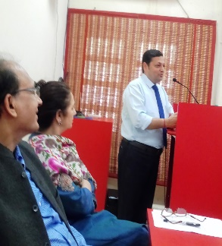 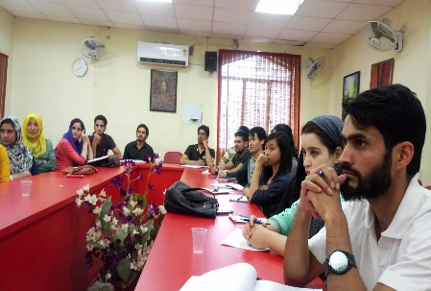  Dr Nishchal Pandey delivering the lecture | JMI, Delhi | 16th May, 2017
- 40) | Lecture on "Media in South Asia" by Anil Giri, Associate editor of The Kathmandu Post; and Dr. Peter Hefele, The Konrad Adenauer Foundation | Nepal | 21st July, 2017
- 41) | Dr. Nishchal N. Pandey, Chairperson, SAF-Nepal with newly appointed Secretary General of SAARC H E Amjad Hussain B. Sial  Dr. Nishchal N. Pandey, , Chairperson, SAF-Nepal with newly appointed Secretary General of SAARC His Excellency Amjad Hussain B. Sial at the SAARC Secretariat in Kathmandu, Nepal | SAARC Secretariat in Kathmandu, Nepal | 7th Aug 2017
- 42) | Mr Sashi Kumar, Director, UNESCO Madanjeet Singh Centre of South Asian Journalism (UMCSAJ) met UMCSAJ's alumni from Nepal | Kathmandu, Nepal | 5th Nov. 2017
SAF-PAKISTAN
- 43) | Mr Koshal Hamal, Alumni of UNESCO Madanjeet Singh Institute for South Asian Arts (UMISAA) Art work is being exhibited  Koshal Hamal, Visual Artist, and SAF, UMISAA Alumni's works are engaged in a synthesis of appropriation, combining Western visual culture with the historical references of South Asian aesthetics-including miniature painting. His appropriations are deeply layered and nuances, interrogating established norms-social, political, and aesthetic-where can break down binary and categories into something new. His works reveal a deep desire of visual play weather through his exquisitely refined miniature painting technique to conceptual installations that provides nuanced narratives of the local and global.  Born in 1988 in Mugu, Nepal, received BFA (2011), MA in Art and Design from Beaconhouse National University, Lahore (2014), on a South Asia Foundation Scholarship. Hamal’s work was awarded as one of the best awards for young artists by Lahore Art Council (2012). Hamal’s works have been selected in several South Asian art exhibitions nationally and internationally, including “New Selections: South Asia”, Thomas Erben Gallery, New York (2012), “Day After Tomorrow”, Alhambra Art Gallery, Lahore (2012) and “South Asian Artists: Imagining Our Future Together”, Dhaka, New Delhi, Washington D.C. (2012), Co Creative Connections 4, Galeria Geraldes Da Silva Rua Santo lldefonso, Portugal (2015). Hamal currently teaches at Tribhuvan University, Fine Art Campus. | The India Art Fair, Exhibition Grounds, Okhla Industrial Estate, Delhi, India | 2nd Feb. 2017
- 44) | Mohammad Mainul Islam, SAF Scholar of UNESCO Madanjeet Singh Institute for South Asian Arts (UMISAA) attended Dubai Art Fair  Sustainable Livelihood  Handicrafts have been a source of livelihood for a large number of artisans in the Subcontinent. This project is an attempt to provide a platform to the artisans who employ organic materials and weaving in their practice. Initiating awareness about the diverse craft traditions of the Subcontinent, the project blends two indigenous craft practices; jamdani and dhurrie from Bangladesh and Pakistan. Engaging the artisan community to create contemporary designs with natural dyes, the vision of this project touches upon sustainability, both in the process and the organic nature of final works. Products range from exquisitely hand-woven, hand embroidered and natural dyed textiles, reviving the flat-weave craft using hand-loom. Protecting and preserving the knowledge and skills is a big challenge and ensuring sustainable livelihood for these artisans is a bigger challenge. With this focus, my aim is to give back to the artisan community by recognising the value of their craft for them as well as society as a whole.  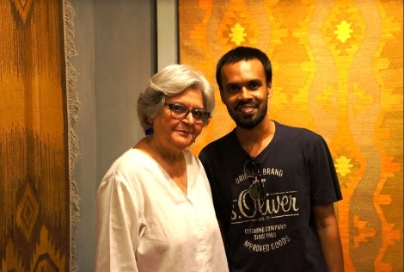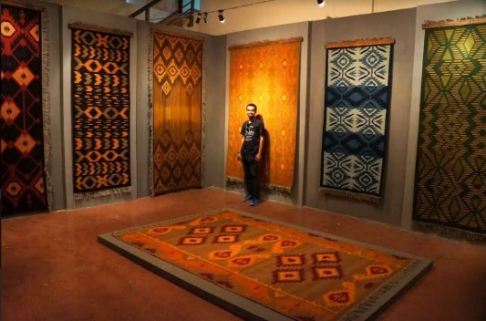  Prof. Salima Hasmi, Director, Art work by SAF Scholar Md Mainul Islam  UMISAA with SAF scholar, Md Mainul Islam | Dubai | 25th April 2017
- 45) | Latest Art-works by Mr Shimul Saha, UMISAA, Alumnus  Shimul Saha (b. 1983, Tangail) is a Dhaka based visual artist, who receieved his BFA degree in Sculpture from Faculty of Fine Art, University of Dhaka in 2005, and an MA degree in Art and Design Studies from UNESCO Madanjeet Singh Institute for South Asian Arts (UMISAA), Beaconhouse National University, Lahore in 2013.  As a visual artist Shimul is interested in tangible materials, although sometimes intangible ideas result through sound and video works. Every time Saha likes to explore different materials to produce his work. He selects materials and techniques according to his work notions. His art practice is based on experiment that develops through research. Sometimes Saha produces bodies of work through series, where experiment and variation of materials are visible in terms of research quality.  Shimul is an active trustee of Britto Arts Trust. Alongside his art practice Saha is teaching at Pathshala South Asian Media Institute and working as a research associate of Bengal Foundation in Dhaka.  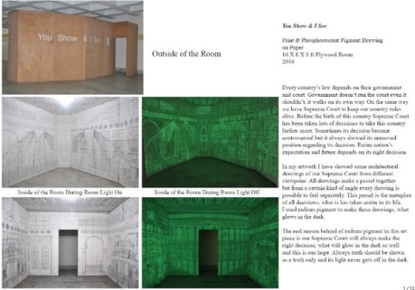 |  | 25th May 2017
- 46) | Artwork by Ms Kubra Khademi, UMISAA Alumini During EMPREMPTA festival, 2017  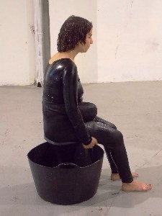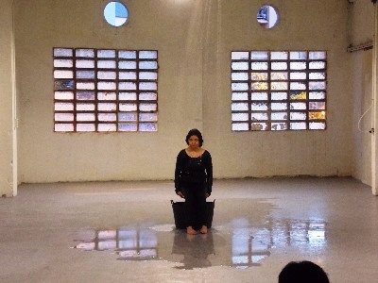  Title: 18Kg Performance  Duration: 40 minutes  Material: Sea salt, water, water pipe, small stool  Festival: EMPREMPTA festival, 2017. Barcelona, Catalonia/Spain  Statement:  The journey continues within the earth, the mother earth, the female mother, the female body, the feminine body with curves - filled with salt which insists on herself, on her salty self. a pregnant woman just like a very much woman. a desired woman, a successful woman who gives birth, who gives life to a living being. The shape disappears slowly and gently in the presence of everyone; her presence, the audience and the water that was ingressing into her body-earth, washes and demolishes her body.  Le voyage continue à l’intérieur de la terre, la terre-mère, la mère femelle, le corps femelle, le corps féminin avec des courbes - rempli du sel qui la renvoie à elle-même, à son sel intérieur  Une femme enceinte, surféminine. Une femme désirée, une femme réussie qui donne naissance, qui donne vie à un être vivant. La forme disparaît lentement et doucement en présence de chacun.  Elle, sa présence en ce temps, le public et l'eau qui coulait dans sa terre-chair, lavent et démolissent son corps. | Barcelona, Catalonia, Spain | 28thJune 2017
- 47) | Cross-border Philanthropy: An Indian diplomat who offered to fund his alma mater in Lahore  Lahore’s Government College’s Vice Chancellor Khalid Aftab wanted to retain the institutional memory of the pre-Partition Ravians — as old GC students were called — who had moved to India. | Lahore, Pakistan | 10th July 2017
- 48) | Mr. Farrukh Adnan, SAF Alumini, UNESCO Madanjeet's Singh Institute for South Asian Studies (UMISAA) held Solo Exhibition  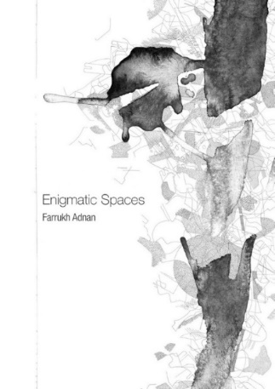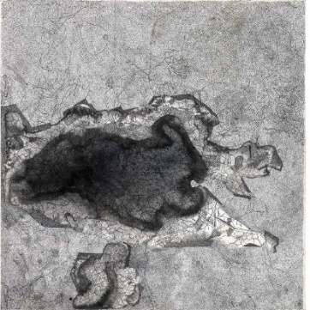 | Lahore, Pakistan | 18th July 2017
- 49) | Prof Salima Hashmi, Director, UMISAA with two SAF, Sri Lankan Scholars Thavarasa Thajendran and Sivasubramaniyam Kajendran in Art Studio  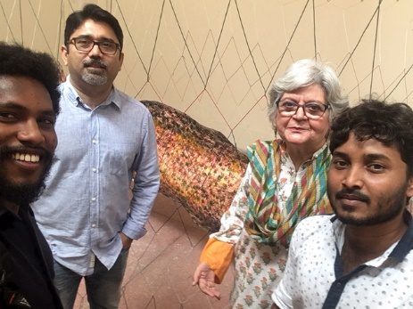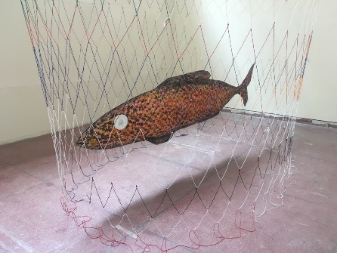 | Lahore, Pakistan | 22nd July 2017
- 50) | UMISAA scholar Ms. Sana Obaid will present De-War Wall, a multimedia exhibition at Open Source Gallery  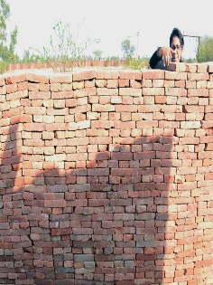  Sana Obaid presents دیوار | De-war | Wall, a multimedia exhibition at Open Source Gallery.  At a time when it is more important than ever to address the political and social significance of walls, travel and immigration, Sana Obaid will present دیوار | De-war | Wall at Open Source, an exhibition that explores borders and boundaries. دیوار | De-war | Wall will incorporate Obaid’s work with elements of life, such as her visa rejection letter, to create work that examines how she has not only been affected by metaphorical walls, but also political and social barriers that have prevented her movement and progress. As a work in progress, the exhibition will change throughout the month, transforming with the addition of video from Obaid’s performances in Pakistan, artist talks and volunteer-executed performances in Brooklyn.  In 2015, artist Sana Obaid submitted a proposal for a piece titled Making a Brick Wall during an open call for exhibitions. The proposal included a performance where the artist would create a wall around herself using fired bricks. Obaid described how, as a Pakistani woman, the society in which she lives has encouraged walls, limiting her experience of life. دیوار | De-war | Wall is an evolution of Obaid’s original proposal, exploring how walls can act as a metaphor, or even literal manifestation, for safety and comfort, yet block views of and interactions with our surroundings and our neighbors.  Obaid’s exhibition was scheduled for 2017. In late 2016, Open Source was notified that we had been awarded a grant from the National Endowment for the Arts to support Obaid’s exhibit. In early 2017, Obaid began the process of applying for a visa to travel to the United States for the exhibition. In March 2017, Obaid’s daughter was born. In June 2017, Sana Obaid’s visa was denied.  Sana Obaid was trained as a miniaturist at the National College of Arts (Pakistan) and received her Masters in Art and Design at Beaconhouse National University (Pakistan). She has exhibited throughout Pakistan as spaces such as Alhamra Gallery, Art Scene Gallery, IVSAA Gallery and Chawkandi Gallery. She has also exhibited outside Pakistan in spaces such as Herbert Gallery (UK), Glynn Vivan Gallery (UK) and Annant Gallery (India).  This exhibition is supported by the National Endowment for the Arts. | Lahore, Pakistan | 2nd Aug. 2017
- 51) | Mr. Rashid Rana, Dean of UMISAA (UNESCO Madanjeet Singh Institute of South Asian Art), at Beaconhouse University  In view of Independence Day on August 14, all of August, the Daily Times will highlight individuals who continue to make Pakistan proud. Our 15th interview is with the immensely talented, award winning artist who has showcased his work internationally. | Lahore, Pakistan | 15th Aug. 2017
- 52) | Art work of Mr Moonis Ahmad, Alumnus, UMISAA Batch (2012-16)  Mr. Moonis Ahmad a BFA graduate of 2016 batch from UMISAA currently is a Doctoral Candidate researching in Archive at the University of Melbourne which ranks amongst top 30 universities in the world. His Studies are fully funded under Australian Graduate Research and Training Programme scholarship which covers his tuition and living expenses in Melbourne Australia. He is also a recipient of VCA Access Mentorship Program at the University of Melbourne.... | Melbourne, Australia | 1st. Nov. 2017
- 53) | UMISAA scholars Mr. Sher Ali & Ms. Lati Attaii selected to participate in young subcontinent project of Serendipity Arts  UMISAA scholars, Sher Ali and Ms. Lati Attaii from Afghanistan nominated to participate in young subcontinent project of Serendipity Arts Festival. The project curated by Riyas Komu and it showcased works of 21 young emerging artists of the Indian subcontinent. The exhibition happened in Public Work Department of Goa - India 15th -22nd Dec 2017 | Goa, India | 15th Dec. 2017
SAF-SRI LANKA
- 54) | SAF Governing Council Meeting held at The Mount Lavinia Hotel in Sri Lanka on 17 January, 2017  The Annual SAF Governing Council, Consisting of the Eight Chapter Heads, met at the Mount Lavinia Hotel in Sri Lanka on 17th Jaunary 2017. The meeting was Chaired by The SAF- Sri Lanka Chairperson, H.E. Ms Chandrika Bandaranaike Kumaratunga | Colombo, Sri Lanka | 17th Jan  2017
- 55) | MoU renewed between the University of Moratuwa and the South Asia Foundation for the establishment of UMCSAWM  MoU is renewed between the University of Moratuwa and the South Asia Foundation for the establishment of UMCSAWM for five years. | UMCSAWM, Moratuwa, Sri Lanka | 23rd March 2017
- 56) | UNESCO Chair on Water Management at UMCSAWM, Moratuwa University in Sri Lanka  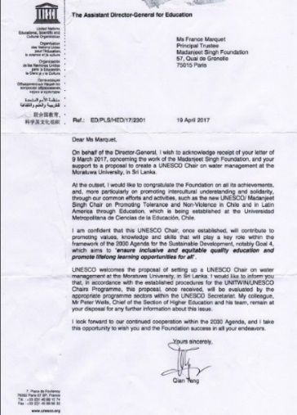 | Moratuwa University, Sri Lanka | 19th May 2017
Other Activities
- 57) | Mme France Marquet representative of SAF to UNESCO attended 'International Day of Women and Girls in Science'  This International Day of Women and Girls in Science is an opportunity for all to take a stand for girls and women in science.  Girls continue to face stereotypes and social and cultural restrictions, limiting access to education and funding for research, preventing them from scientific careers and reaching their full potential. Women remain a minority in science research and decision-making. This throws a shadow over all efforts to reach the 2030 Agenda for Sustainable Development and the Paris Agreement on Climate Change – both of which highlight the key roles of gender equality and science.  At the same time, girls and women shoulder the heaviest burdens of poverty and inequality – they stand on the frontlines of climate change, including the disasters resulting from natural hazards. Girls and women in rural and disadvantaged areas are hit hardest.  Meaningful progress must start with the rights and dignity of women, by nurturing their ingenuity and innovation.  This message was sent during the last two Conferences of the Parties of the United Nations Framework Convention on Climate Change (COP 21 and 22) by Mme Irina Bokova, Secretary General, UNESCO Headquaters, Paris.  "Humanity cannot afford to ignore half of its creative genius. Girls and women must be empowered at every level, in learning and research, from administration to teaching, across all scientific fields. This goal underpins the Manifesto ‘For Women in Science’ that UNESCO launched last year with the L’Oréal Foundation, to engage Governments and stakeholders in promoting the full participation of girls and women in science. We must inspire girls and young women by offering mentoring opportunities to young women scientists to assist in their career development. We must raise awareness about the work of women scientists by providing equal opportunities for their participation and leadership in a broad spectrum of high-level scientific bodies and events." | UNESCO Headquaters, Paris, France | 11th Feb. 2017
- 58) | Mme France Marquet representative of SAF to UNESCO attended award ceremony of the UNESCO King Hamad Bin Isa Al-Khalifa Prize  The award ceremony took place from 12 pm to 1 pm in Room II in the presence of the Director-General of UNESCO, Mme Irina Bokova and His Excellency Dr. Majed Bin Ali Al-Noaimi, Minister of Education of the Kingdom of Bahrain.  The ceremony preceded by the Laureates' Seminar about the use of ICTs in Education for disadvantaged groups, which gave the floor to the two 2016 Prize winners. | UNESCO Headquaters, Paris, France | 21st Feb. 2017
- 59) | Mme France Marquet representative of SAF to UNESCO attended the conference on 'Diplomacy in the Age of Social Media' | UNESCO Headquaters, Paris, France | 1st March 2017
- 60) | Mme France Marquet representative of SAF to UNESCO attended "Mobile Learning Week"  Co-organized by UNESCO and UNHCR Mobile Learning Week 2017 held under the theme ‘Education in emergencies and crises’ from 20 to 24 March in Paris.  To expand international understandings of how new and affordable technologies can help:  - Strengthen inclusion in education  - Preserve the continuity of learning in conflict and disaster contexts  - Open and enrich learning opportunities for refugees and other displaced people  - Facilitate the integration of learners in new schools and communities  - Catalyze innovation in the education sector and improve the impact of humanitarian interventions | UNESCO UNESCO Headquarters, Paris, France | 20th March 2017
- 61) | Mme France Marquet representative of SAF to UNESCO attended the colloquium “Journalism under Fire: Challenges of our times”  UNESCO organized two round table discussions in order to provide a global platform to assess the international landscape facing media actors. Thus, media leaders, journalists, experts and Member States will have an opportunity to analyze the extent to which there is a “crisis of journalism”, and unpack the main driving forces involved. The format of both round tables will generally not be speeches, but television - style discussion and debate with a panel, as well as audience interaction.  Organized in association with the International Programme for the Development of Communication, this colloquium will be held at UNESCO Headquarters within the framework of the La Presse en Liberté week of 22 to 29 March 2017, which includes a series of round tables on topics related to press freedom and an exhibition of original front pages of newspapers’ first editions. The week is co-organized by UNESCO together with the Permanent Delegation of Switzerland to UNESCO and the Permanent Delegation of France to UNESCO. | UNESCO Headquarters, Paris, France | 23rd March 2017
- 62) | Mme. France Marquet Principal Trustee, MSF and SAF attended seventh International Forum of NGOs  Organized by the NGO-UNESCO Liaison Committee and UNESCO, in partnership with the Mohammed bin Salman bin Abdulaziz Foundation (MiSK), the Seventh International Forum of NGOs in official partnership with UNESCO was held in Riyadh (Saudi Arabia) on 3 and 4 May 2017.  The topic chosen for this Forum - “Youth and their Social Impact” fits UNESCO’s mandate and its actions related to youth, and meets the strong focus on youth given by the 2017 International Conference of NGOs held in Paris in December 2016.  Using an engaging format, the 2017 Forum brought together NGOs in official partnership with UNESCO, youth representatives and experts intended to become a call for action and a platform to enable participants to co-create initiatives and select high-impact ideas.  Through keynote conferences and panel discussions, the Forum will mainly focus on the following topics:  - Youth Engagement and Its Potential for Social Change  - Optimizing the Impact of the Digital Native – and Managing the Risk  - Educating for a Sustainable Future  - What Skills for Young People Today?  Breakout sessions will delved more specifically into the following sub-themes:  - Youth Entrepreneurship and Volunteering: Promoting Engagement at Local and International Levels  - Protection of Cultural Heritage: Can Young People Make a Difference?  - Using Digital Tools for the Promotion of Social Interaction and Engagement  - Maximizing the Fight Against Climate Change for Sustainable Development  - Fostering Equal Opportunities for Young Men and Women  - Ensuring Complementarity between Formal and Informal Education  More information on the programme and logistics are available under the url unescongoforum2017.com, where participants can also register.  Extensive information on the Forums of NGOs in official partnership with UNESCO and the work coordinated by the NGO-UNESCO Liaison committee are available on the NGO-UNESCO Liaison Committee’s website | Riyadh, Saudi Arabia | 5th May 2017
- 63) | Mme. France Marquet represtative of SAF to UNESCO attended the International Vesak Day on 10 May 2017  On the occasion of the commemoration of Vesak, a United Nations declared International Day of Observance, Tilak Ranaviraja, Ambassador, Permanent Delegate of Sri Lanka to UNESCO requested the presence on symposium organized on the theme “ Buddhism and Promotion of Sustainable Peace” followed by cultural performance and a reception. | UNESCO Headquaters, Paris, France | 11th May 2017
- 64) | Mme France Marquet representative of SAF attended the meeting of the UNESCO Chairs in human rights, urban inclusion & migration  A Meeting of UNESCO Chairs in human rights, urban inclusion and migration was held at UNESCO Headquarters in Paris on 21 and 22 June 2017.  The objectives of the Meeting were:  1) Contribute to launching the process of the review of UNESCO’s Human Rights Strategy and the Integrated Strategy to Combat Racism, Discrimination, Xenophobia and Related Intolerance, both adopted in 2003, bearing in mind the priorities of the 2030 Agenda for Sustainable Development and the New Urban Agenda; and  2) Develop jointly a comprehensive roadmap for collaboration with Chairs and Institutes with emphasis on the promotion of human rights, urban inclusion and migration.  Participants will comprise representatives of UNESCO Chairs and Institutes, experts, as well as representatives from civil society. Taking into account the importance of local action, local authorities from the International Coalition of Inclusive and Sustainable Cities − ICCAR from all regions are invited to participate as well. The participation of all UNESCO programme Sectors throughout the process is crucial to target debates and help generate recommendations on intersectoral actions and initiatives.  Partnering with UNESCO Chairs in human rights, urban inclusion and migration will contribute to better position UNESCO for the promotion of human rights and the attainment of the 2030 Agenda for Sustainable Development. | UNESCO Headquarters, Paris, France | 23rd June 2017
- 65) | Mme France Marquet SAF representative attended the forum: UNESCO's Soft Power Today: Fostering Women's Empowerment and Leaders  UNESCO fulfils its mission through advocacy for peace and development and through the soft power of persuasion. To highlight this key instrument, UNESCO is organizing a series of thematic conferences within the framework of “UNESCO’s Soft Power Today”. The series will be launched on June 30 with a High-level Conference on “Fostering Women’s Empowerment and Leadership”, highlighting Gender Equality as one of UNESCO’s two Global Priorities.  The High-level Conference gathered over 50 high-level personalities and renowned experts from around the world and served as a platform to celebrate UNESCO’s achievements and to identify promising pathways for inclusive and innovative partnerships to work on women and girls’ empowerment and leadership. The day was be organized in three thematic sessions. Each panel presented the state of the art through the participants’ experiences and work; (2) discuss the challenges and innovative solutions in the 2030 horizon, and (3) leveraging on UNESCO’s role and added value. | UNESCO Headquarters, Paris, France | 2nd July 2017
- 67) | Agreement Concerning the establishment of a UNESCO/Madanjeet Singh Chair on Promoting Tolerance and Non-Violence  Agreement Between The United Nations Educational, Scientific And Cultural Organization And Universidad Metropolitana De Ciencias De La Educacion Concerning The Establishment Of A Uneso/ Madanjeet Singh Chair On Promoting Tolerance And Non-Violence In Chileand In Latin America Through Education At Universidad Metropolitana De Ciencias De La Educacion (Santiago De Chile, Chile) | Chile and in Latin America through Education, Santiago de Chile | 4th Sep. 2017
- 68) | Inauguration of the UNESCO Madanjeet Singh Chair on promoting tolerance and non-violence in Chile and Latin America  H.E. Michelle Bachelet, The President of Chile, receives Mme France Marquet, Trustee of Madanjeet Singh Foundation and Mr Francisco Javier Estevez Valencia, laureate 2014 of the UNESCO Madanjeet Singh prize for the promotion of tolerance and non-violence at the the Universidad Metropolitana de Chile (UMCE-Pedagogico)  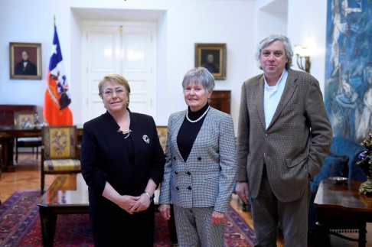  The Chair aims to promote the values of the UNESCO-Madanjeet Singh Prize for the Promotion of Tolerance and Non-Violence, to contribute to fostering a culture of inclusion, rights and citizenship, and to strengthen the values of tolerance and non-violence at universities and higher education institutions, including teacher training institutions, in Chile and Latin America.  The Chairholder, Professor Francisco Javier Estévez Valencia, is the co-laureate of the 2014 edition of the Prize. Historian and the Executive Director of the Museum of Human Rights and Memory in Chile, he started his non-violent struggle for human rights and democracy during the years of the dictatorship of Augusto Pinochet and became one of the well-known leaders of the democratic resistance of young Chileans. As coordinator of the Cinta Amarilla citizen campaign, he contributed to the abolition of the death penalty in Chile in 2001, and to the removal from the public space of monuments symbolizing the military regime.  France Marquet and Francisco Javier Estévez Valencia met with Michelle Bachelet Jeria, President of Chile, on 6 October 2017 and visited the Ministry of Education and the UNESCO National Commission for Chile.  The UNESCO-Madanjeet Singh Prize for the Promotion of Tolerance and Non-Violence was established in 1995 on the occasion of the United Nations Year for Tolerance and the 125th anniversary of the birth of Mahatma Gandhi. It is awarded every two years to individuals or institutions for their outstanding contribution to the promotion of tolerance and non-violence and aims to advance the spirit of tolerance in the arts, education, culture, science and communication. | Palacio de la Moneda, Santiago, Chile | 2nd Oct. 2017
- 69) | Mme France Marquet paid a visit to the Universidad Metropolitana de Chile (UMCE-Pedagogico)  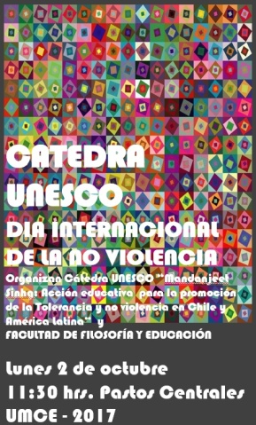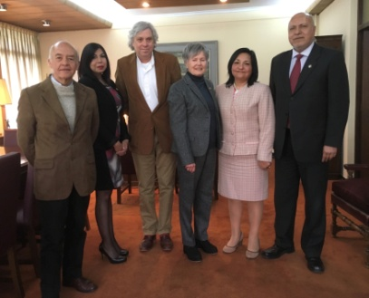 | UMCE, Chile | 2nd Oct. 2017
- 70) | Madame France Marquet, Trustee MSF and representative SAF to UNESCO paid a visit to the Chilean National Human Rights Commission  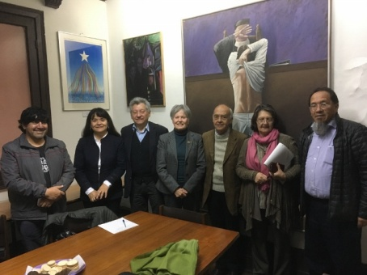  Visit to the Chilean National Human Rights Commission, from left to right Mr. Juan Rain, Ms. Patricia Soto, Mr. Carlos López, (President of the National Commission) Mme. France Marquet Trustee, Madanjeet Singh Foundation (MSF), Mr. R. Hernández Executive Director of the UNESCO Madanjeet Singh Chair of tolerance and non-violence, Ms. Carmen Pinto (archivist), Mr. Luis Moya (Vice President of the Commission). | La Clinica, Chile | 2nd Oct. 2017
- 71) | Reception of Mme. France Marquet at the Universidad Simon Bolivar by the Chancellor Dr Manuel Jacques followed by a Seminar  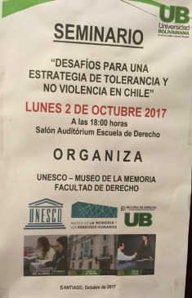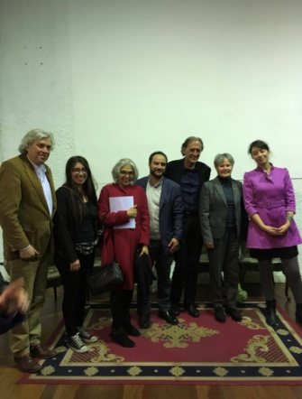 | Santiago,  Chile | 2nd Oct. 2017
- 72) | Visit to Museum: Memory and Human Rights  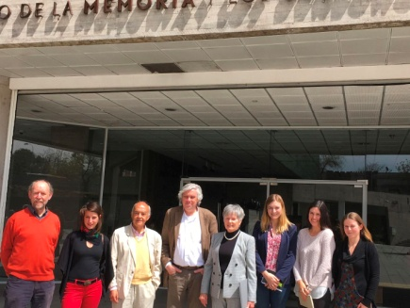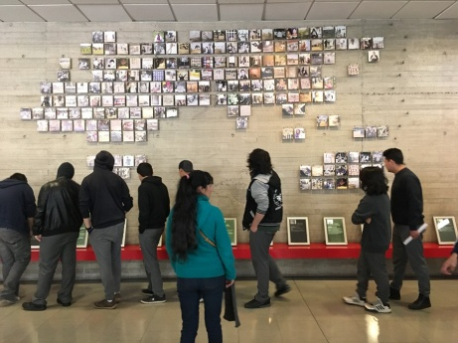 |  | 3rd Oct. 2017
- 73) | Audience with H.E President Michelle Bachelet, of Chile as the Palacio de la Moneda  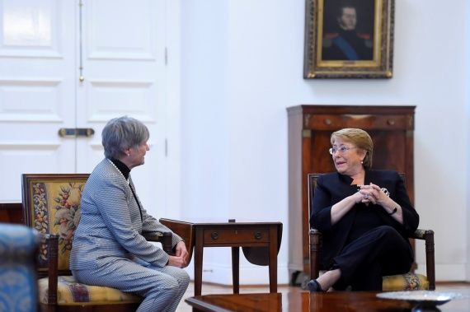  Madame France Marquet, Trustee, MSF and representative of SAF to UNESCO calls on with H.E president Michelle Bachelet of Chile. | Santiago,  Chile | 3rd Oct. 2017
- 74) | Mme France Marquet, Trustee, Madanjeet Singh Foundation, visited Ministry of Education, UNESCO National Commission, Chile  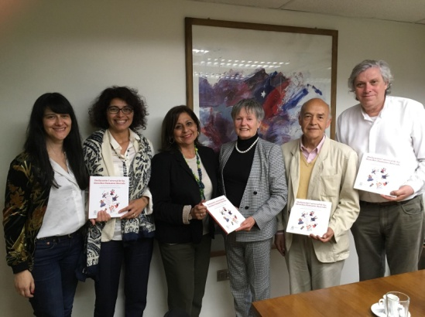  From left to right: Monica Salineros, Cecilia Barbieri, (Senior Education Specialist Director, UNESCO Santiago Office) Elizabeth Rubio (Head International Affairs Office and Gender, Ministry of Education ,Chile) Mme France Marquet, (Trustee MSF-SAF) Ramon Hernandez, (Executive Secretary, UNESCO Madanjeet Singh Chair for tolerance and non-violence Universidad Metopolitana de Santiago) Francisco Estevez (Laureate UNESCO Madanjeet Singh prize for the tolerance and non-violence 2014). | Santiago, Chile | 3rd Oct. 2017
- 75) | Reception at PEN Club International de Chile  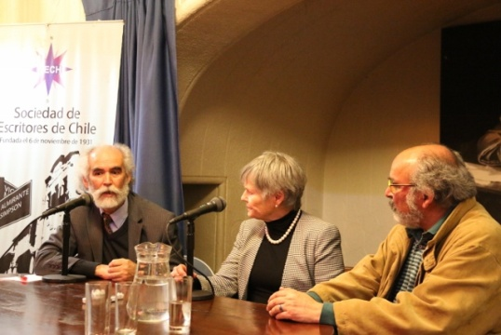  Reception at PEN Club International de Chile, from Left to right: Mr. Manuel Andros Vice President of the Pen Club), Mme. France Marquet Trustee Madanjeet Singh Foundation (MSF) and Mr. Jorge Ragal (President of the Pen Club). | Pen Club, Chile | 3rd Oct. 2017
- 76) | Visit to the Pablo Neruda Foundation, La Chascona Santiago, Chile  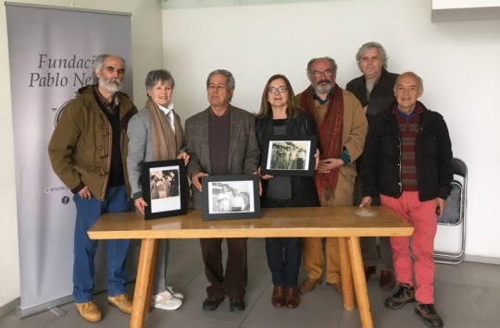  Gift to the Neruda Foundation of the Portraits of Pablo Neruda in India and with Famous Urdu Poet Faiz Ahmad Faiz  Left to right: Mr Manuel Andros, Vice President, PEN Club, Mrs France Marquet,Trustee MSF-SAF (with photograph of the famous Punjabi writer Navtej Singh , Editor of Preet Laree with Nobel Prize laurate Pablo Neruda); Sr Darío Oses, Director of the Library of the Pablo Neruda Foundacion (with the photo of Nobel Prize laurate Pablo Neruda and famous Urdu Poet Faiz Ahmad Faiz ; and Mrs Carolina Briones, (Archivist) with the photograph of Pablo Neruda Matilde Neruda, Faiz Ahmad Faiz, Salima Hashmi Faiz; Jorge Ragal (President of PEN Club); Mr Fransico Javier Estevez, Director of Meusum, Memory and Humen Rights Meusum and Mr Ramon Hernandez, (Chair UNESCO Madanjeet Singh, UMCE) | La Chascona Santiago, Chile | 4th Oct. 2017
- 77) | Visit of Mme France Marquet Trustee, Madanjeet Singh Foundation to Lago Budi  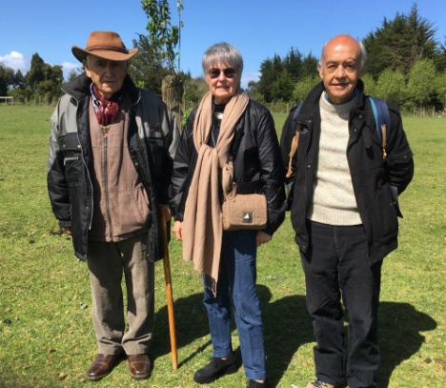  Left to right : Lonko (Head) Mr Juan Rain; Mme. France Marquet Trustee, Madanjeet Singh Foundation & Mr Ramon Hernandez, Chair UNESCO Madanjeet Singh UMCE in the Mapuche, Lafkenche region community Hualtin | Lago Budi, Chile | 9th Oct. 2017
- 78) | Visit to radio Werken Kuruf at Mapuche Community  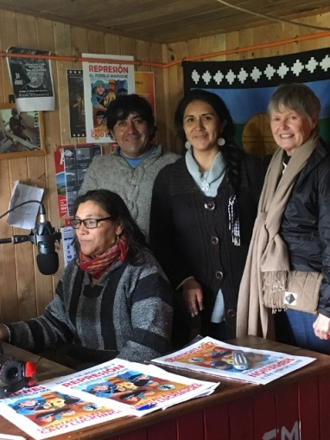  From left to right: Mr. Juan Rain, Ms. Silvia Calfuqueo (Director of the Mapuche school), Mme. France Marquet Trustee Madanjeet Singh Foundation, and Ms. Ivonne Gonzalez. | Mapuche, Chile | 10th Oct. 2017
- 79) | Visit to the School- Kom Pu Lof Ni Kimeliuwe  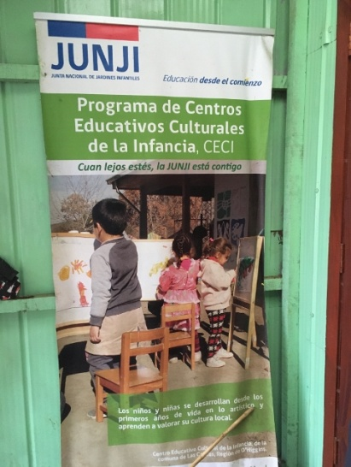 | Chile | 10th Oct. 2017
- 80) | Madame France Marquet, Trustee, MSF & SAF representative to UNESCO attended Knowledge Forum on Water Security and Climate Change  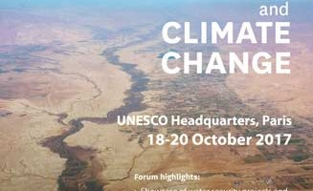  When, local time: Wednesday, 18 October 2017 - 9:00am to Friday, 20 October 2017 - 6:00pm  Where: UNESCO Headquarters, Paris, France  Type of Event: Category 7-Seminar and Workshop  Contact: k.verbist@unesco.org  UNESCO-International Hydrological Programme organizes the Knowledge Forum on Water Security and Climate Change. The aim of the Knowledge Forum will be also to facilitate knowledge exchange and to develop new projects. Featured activities of the Knowledge Forum on Water Security and Climate Change: | UNESCO Headquarters, Paris, France | 18th Oct. 2017
- 81) | Madame France Marquet, Trustee, MSF & SAF representative to UNESCO attended 39th Session of the General Conference  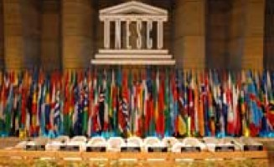  When, local time:Monday, 30 October 2017 - 10:00am to Tuesday, 14 November 2017 - 6:00pm  Where: France, Paris  Type of Event: General Conference  The General Conference consists of the representatives of the States Members of the Organization. It meets every two years, and is attended by Member States and Associate Members, together with observers for non-Member States, intergovernmental organizations and non-governmental organizations (NGOs). Each country has one vote, irrespective of its size or the extent of its contribution to the budget.  The General Conference determines the policies and the main lines of work of the Organization. Its duty is to set the programmes and the budget of UNESCO. It also elects the Members of the Executive Board and appoints, every four years, the Director-General. The working languages of the General Conference are Arabic, Chinese, English, French, Russian and Spanish. | UNESCO Headquarters, Paris, France | 30th Oct. 2017
- 82) | Madame France Marquet attended Asia-Pacific Regional Workshop on Global Action Programme on Education & Sustainable development  When, local time: Tuesday, 28 November 2017 - 9:00am to Thursday, 30 November 2017 - 6:00pm  Where: India, New Delhi  Type of Event: Category 7-Seminar and Workshop  Contact: s.yano@unesco.org  The Asia-Pacific regional workshop, organized by UNESCO in partnership with the Ministry of Human Resource Development, India and with the support of the UNESCO Institute for Lifelong Learning (UIL), the United Nations University Institute for the Advanced Study of Sustainability (UNU-IAS), and Japanese Funds-in-Trust for ESD, will be held from 28 to 30 November 2017 in New Delhi, India.  UNESCO is promoting ESD through the Global Action Programme (GAP) on ESD, the official follow-up to the UN Decade of ESD. It focuses on generating and scaling up ESD action at all levels and in all areas of education, and in all sustainable development sectors. The 17 SDGs provide the wider context for the further upscaling and mainstreaming of ESD.  One of the five Priority Action Areas of the GAP focuses on mainstreaming ESD at local level. Ensuring efficient GAP implementation to enhance and integrate ESD at local level means mobilizing local municipalities and communities, ensuring they have sufficient capacities in ESD, strengthening learning opportunities for citizens in various settings, and promoting collaboration among relevant local stakeholders in different sectors.  To this end, UNESCO, as the lead agency for ESD, is organizing workshops for cities/municipalities in all five UN regions between December 2016 and March 2018. The regional workshops are a crucial element in accelerating sustainable solutions and scaling up ESD actions at local level, taking into account regional priorities in addressing sustainability issues, and the urban specificities in these regions. The provision of ESD training to cities and local authorities is expected to result in communities providing both more and enhanced sustainable development learning opportunities for their citizens. | Lalit Hotel, New Delhi, India | 28th Nov. 2017
- 83) | Madame France Marquet represented MSF at seminar 'Making climate finance work for women'  On the occasion of the One Planet Summit, the Ministry of Europe and Foreign Affairs organised a symposium devoted to climate finance for women:  "Climate finance in action for women"  Monday, December 11, 2017 from 17:00 to 19:00  Minister's Hotel, 35 quai d'Orsay, Paris | French Foreign Affairs Ministry, France, Paris | 11th Dec. 2017

